### **Introduction**

In this document we are discussing about vendors and theirs products.

Purpose of Our-website multi-vendor marketplace is to fulfil the requirement of supply chain management without breaking the cash-flow.

Moto-> Using our-Website Multi-Vendor Marketplace vendor can sell and promote their products online from the merchant’s (admin) shop (website).

### **Purpose**

A Marketplace is a regular gathering of people for the purchase and sale of products and other goods. In other words, it is simply a place where buying and selling occurs.

### **User Characteristics**

**1. Vendor**: Vendor is a person (or a company) who can sell his/her products at merchant's site. Vendor has to sign up first at merchant’s shop for selling his/her products.

After the merchant’s (formally admin) approval, Vendors:

* can have profile section,
* can have add/edit/list/delete product's attributes section,
* can have add/edit/list/delete product section,
* can have order view/cancel/invoice/shipment section for their products (because an order may contain multiple vendor's products),
* can have sales reporting section for their orders,
* can have commission section from where they can add their bank detail etc and also view the commission and statistics of sales,
* can have mass import/export section for products and categories,
* can have rating/review section for their products,
* can have a landing page for their products with their logos, about vendor information etc.

**2. Merchant (formally admin)**: Merchant (formally admin) is the owner of the shop who can manage all the activities of every vendor. Every action performed from the vendor panel by the vendor is a must to be approved by the merchant (formally admin), only after that it will be available online at the shop. Merchant (formally admin) has the authority to disable any function of the vendor at any time.

Merchant (formally admin) has the following possible menus:

* Manage Vendors,
* Manage Vendor's Products
* Manage Vendor's Sales,
* Manage Vendor's Commission,
* Vendor Configurations.

## **Vendor Registration Process**

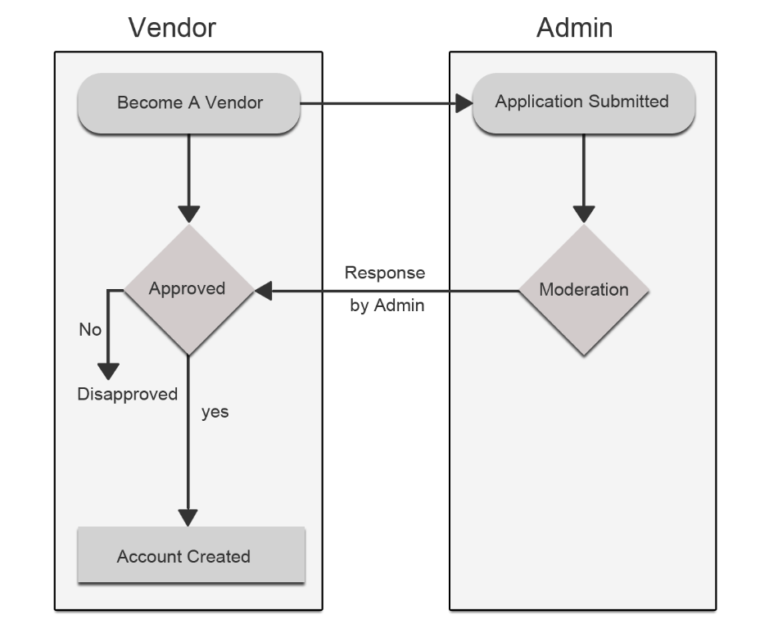

### **New Vendor**

Anyone can be registered as a vendor from "Create New Account" link.

### **Become a Vendor**

An existing customer can also become a vendor through the Approval Page.

### **Public Name**

Public Name is the Display Name/Brand Name of the vendor. Public Name will be used "At Marketplace Page", "At Shop Page", "At Order View", "At Transaction View", "At Invoice View", "At Print View" etc.

### **Shop Url**

Shop Url is a unique URL key throughout the vendor system. Shop Url key will be used for creating a unique URL for vendor shop.

### **Approval/Disapproval**

Admin has the authority to approve/disapprove every new vendor. The admin can also enable the Auto approval option for the vendor in which case every new vendor will get approved automatically.

But admin has the authority to disapprove a vendor at any time from the admin panel.

### **Vendor Shop Enable/Disable**

Admin has the authority to enable/disable the shop page of the approved vendor at any time.

## **Account Management**

Every Approved Vendor has an Account Panel (say Vendor Panel) to manage their profile, products, sales, reports, settings and many more according to their group settings and membership plans.

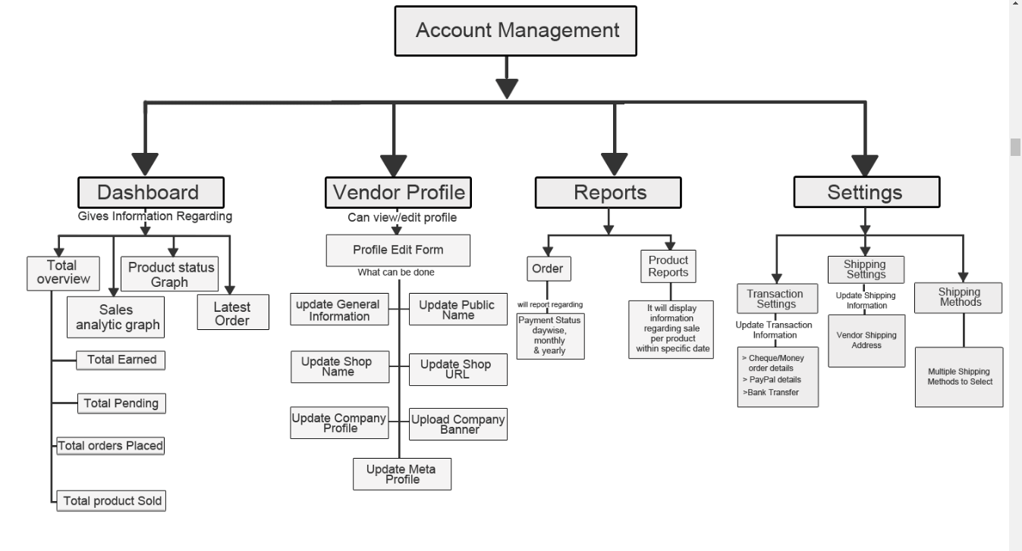

### **Dashboard**

Dashboard is a resource panel of vendor from where the vendor has the ability to view a snapshot of their **Total Pending Amount**, **Total Earned Amount**, **Total Orders Placed**, **Total Products Sold**, **Sales Analytics (Today, Week, Month and Year)**, **Products Status**, **Latest Orders**, **Area Wise Orders** and **Chat*\**** .

**Total Pending Amount**: An amount which the admin has to pay to the vendor for the purchased products.

**Total Earned Amount**: Total amount earned by the vendor from their sold products.

**Total Orders Placed**: Number of orders placed by the buyers for vendor's products.

**Total Products Sold**: Total Products Quantity sold.

**Sales Analytics (Today, Week, Month and Year)**: It depicts a sales graph having “Recent Time Range” versus “Number of Placed Orders” where the “Recent Time Range” can be current 24 hours in the case of Today, can be current 7 days in the case of a Week, can be current 30 days in the case of a Month, can be current 12 months in the case of an Year.

**Products Status**: A count chart which will represent the count of Pending, Approved and Disapproved Products created by the vendor.

**Latest Orders**: Listing of last 5 Order placed for vendor's products.

**Aria Wise Orders**: Country wise sales graph. On hovering at a particular Area/Society the vendor can view the total order count and total sale amount for these orders.

**Chat*\****: A Chat window to communicate with admin for vendor related queries.

### **Profile**

Profile is a resource panel of the vendor from where the vendor has the ability to manage his/her account information.

Account Information is generally divided into four attribute groups** called "**GENERAL INFORMATION**", "**COMPANY INFORMATION**", "**SUPPORT INFORMATION**" and "**SEO INFORMATION**".

**GENERAL INFORMATION**: Generally following inputs comes under this attribute's group:

* Profile Picture(Editable attribute): This is personal picture of vendor or vendor representative.
* Created At(Non-Editable attribute)
* Shop Url(Non-Editable attribute)
* Status/Category
* Vendor Group
* Public Name
* Name
* Gender
* Email
* Contact Number

### **Transaction Settings**

Transaction Settings are used for Admin to Vendor transaction purposes. Whenever the admin has to pay to the vendor then he/she can go to the Transaction Panel and click the Credit Amount or Debit Amount button as per the requirement

Transactions can be made Vendor-wise or Order-wise. In vendor-wise transactions, the Admin can pay to each vendor at a time i.e. one vendor at a time whereas in order-wise transactions the admin can select all the orders of a particular vendor and for pay for them at once. Admin can deduct his commission and pay the remaining amount to the vendor

Refund can also be done by the Admin in case a Refund Request has been generated by the customer. In such a case the Admin has to first generate the Credit Memo of the respective order and then he can Debit the required amount from the vendor’s account

All the transactions carried out are offline transactions for online transaction Vendor PayPal Adaptive Addon can be used

### **Shipping Settings**

This section is for the vendor. Here the vendor has to specify his/her Origin Address i.e the Company Address from where the products will be shipped. This functionality can be achieved by Vendor MultiShipping Addon which acts as a container for all types of shipping methods. Therefore, for using any shipping addon Vendor MultiShipping Addon has to be pre-installed.

### **Shipping Methods**

Vendor can use the available Shipping Methods from the Settings > Shipping Methods settings section in his/her vendor panel.

It displays shipping method-wise settings from where the vendor can set the item-wise or order-wise shipping rates, allowed Aria or export the details from csv depending upon the shipping method

### **Vendor Profile View on Shop Page ?**

The marketplace page displays the shop of every vendor clicking on which the dedicated shop page of the respective vendor gets displayed.

This page shows the relevant profile information of the vendor and his/her contact details as well so that the customers can have an idea about the background of the vendor like his Company details, company logo, banner, company address, telephone number, email-id, social media url (if any), etc

## **Catalog Management**

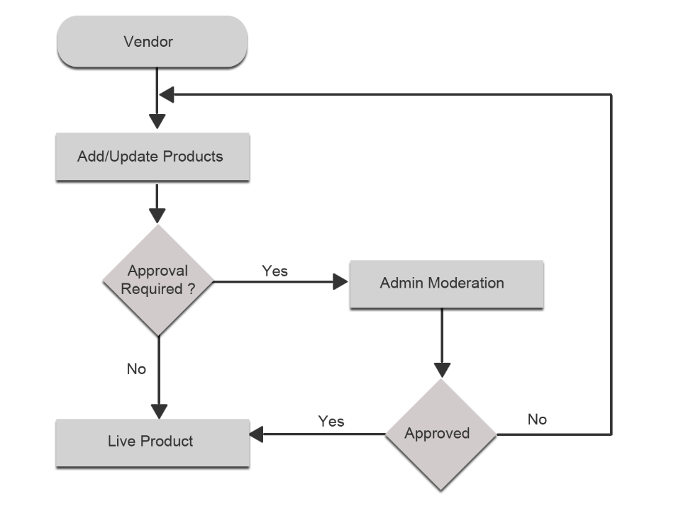

### **Product's Types**

From vendor panel, the vendor has the ability to create all the types of products, i.e. the types of products that the merchant (store admin) can create from the admin panel, all those types of products can be created from the vendor panel at frontend.

*Configurable, Bundle and Grouped products can only be created after installing Vendor Product Addon.

### **Product's Attribute Sets ?**

Every vendor gets an attribute set. When the vendor will create an attribute from the vendor panel for his products, then that attribute will be assigned to this particular attribute set. This way each vendor has his own set of attributes for his product.

* This feature will be available only after installing Vendor Product Attribute Add-on

### **Product's Attributes**

Vendor can create an attribute for his products from the vendor panel. While creating the attribute, the vendor can select the attributes assigned to him for being a vendor. During product creation vendor can use the attribute set to assign the newly created attributes to his products.

### **Product's Pricing**

From the vendor panel, vendor can assign the price to the products in the same way as the admin does. It has all the necessary fields for setting the price of a product similar to the product pricing section in the admin panel.

### **Product's Inventory**

Vendor can set the inventory settings also use the default inventory settings.

### **Product's Categories**

Vendor can assign the products to the available categories created by the store admin. This way vendor’s products will also get listed according to the store’s categories.

### **Product's Websites?**

As mentioned in the above topic i.e. Vendor Website Sharing, Vendor class is the extended form of customer class and customer can share all the websites/specific websites as per admin settings. So as per the admin settings of sharing, the vendor can share his/her products for all the websites/specific websites.

### **Related Products**

Its functionality is adding similar products or related products. But in this the vendor can select from his products only i.e. the products created by him.

### **Admin Moderation?**

Admin has the power to control as many vendor functionalities as he wants. For instance, without admin approval the vendor products are not shown at frontend. Like this there is much other functionality which can be controlled by the admin.

### **Vendor Product Collection on Shop Page**

When a vendor creates a product to show on his shop page, firstly it goes to the admin for approval, and after admin approval the product starts appearing on the shop page. The customer can then easily see the product on the shop page of the vendor.

## **Order Lifecycle**

**Multi-Vendor Marketplace Order Lifecycle**

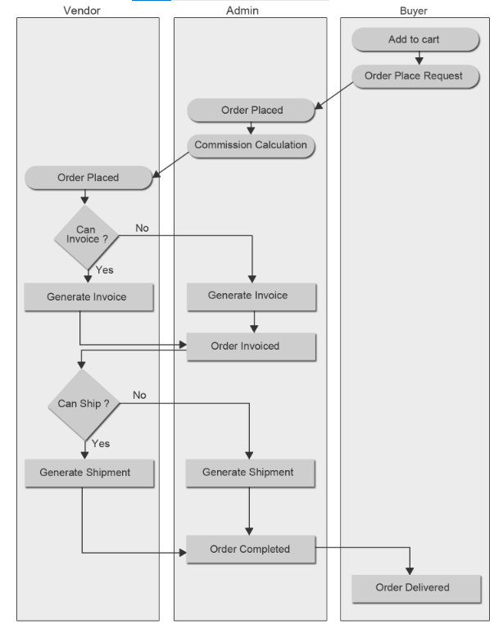

### **Place an Order**

Website Multi-Vendor Marketplace is providing a feature where different sellers can come together and sell their products on the digital marketplace. Any customer can order different sellers' products in a single order. Any cart can be associated with multiple vendor's products.

Here the orders can be placed in two ways-

#### **1) Merge Orders-**

These are the orders which contain different vendors’ products and in this case only one Website order is placed.

Demonstrative Example-

Suppose there are Three vendors "Vendor-A", "Vendor-B" and "Vendor-C" these vendors one product from each vendor has been added to the cart by any customer. Now if the customer placed order for these Vendor's product, then finally one Website order is being placed like Website order 1000009.

#### **1) Split Orders-**

In this case when different vendors’ products are ordered in a single order then different Website orders are placed, and this depends on the number of vendors’ products added to cart.

Demonstrative Example-

Suppose there are three vendors "Vendor-A", "Vendor-B" and "Vendor-C" one product of each vendor has been added to the cart by a customer. Now, if the customer has placed an order for these Vendors’ products, then different Website orders are placed like Website order 1000007, 1000008, 1000009. Website order count is proportional to the count of vendors’ product added to the cart.

### **Commission Distribution**

Commission distribution is an important part in any marketplace. If the Admin has launched his/her marketplace then he will get the commission, and the vendors will get the payments for their sold products.

Admin of any Website store can create the commission rates by going to the System Configuration or Commission setting menu **Website > Vendor Configuration > Vendor Payment (fields)**. The rates can be managed as fixed or percentage. This commission will be paid to the admin and the rest of the payment is made to the vendor.

### **Create Invoice**

Any vendor can create the invoice of any product sold by him. Here the requirement is that he needs to install **Vendor Order Addon**. After installing this extension, the shipping charges have to be applied by the vendor to be eligible to create the invoice. If only **Multi-Vendor Marketplace Basic (free)** version is used then the invoice can be generated by the admin only.

### **Create Shipment?**

Any vendor can create the shipment of any product sold by him. Here the requirement is that he needs to install **Vendor Order Addon**. After installing this extension, the shipping charges have to be applied by the vendor to be eligible to create the shipment. If only **Multi-Vendor Marketplace Basic** version is used, then the shipping can be generated by the admin only.

Admin provide the Shipment for vender or customer.

### **Create Credit Memo**

Credit Memo means refund of any order. Any vendor can create the Credit Memo of any product sold by him for Admin to settlement Payment.

## **Commission Calculation ?**

The calculation of commission in Multi-Vendor Marketplace Basic extension is very easy and accurate. The commission can be applied as Fixed rate or Percentage-wise rate by the admin from Vendor Configuration settings in the admin panel.

To apply enhanced miscellaneous commission rates, Vendor Commission Addon can be used. This addon will allow the admin to impose Product Type-wise or Category-wise commission rates with the feature of min/max rule. The admin will thus, be able to earn more profit in the form of commission with the use of Commission Addon

## **Transaction Lifecycle**

**Transaction Overview**

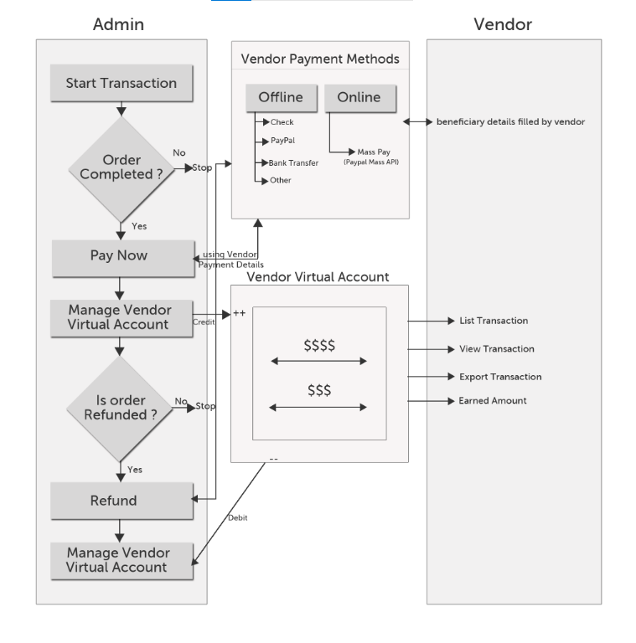

Transaction is a very important part of Website Multi-Vendor Marketplace. Marketplace is a platform where different vendors come together and sell their products on commission basis. So after deducting admin commission the remaining payment will be given to the vendor. The commission can be dependent on the marketplace commission settings. Multi-Vendor Marketplace commission settings can be extended by installing the **Vendor Commission Addon?**. It is the responsibility of the admin to release the vendor payments when the order related to the any vendor is placed. Admin will credit the payment to the vendor’s account from the transaction panel.

## **RMA Lifecycle (**Return merchandise authorization**)**

**Multi-Vendor Marketplace RMA Lifecycle**

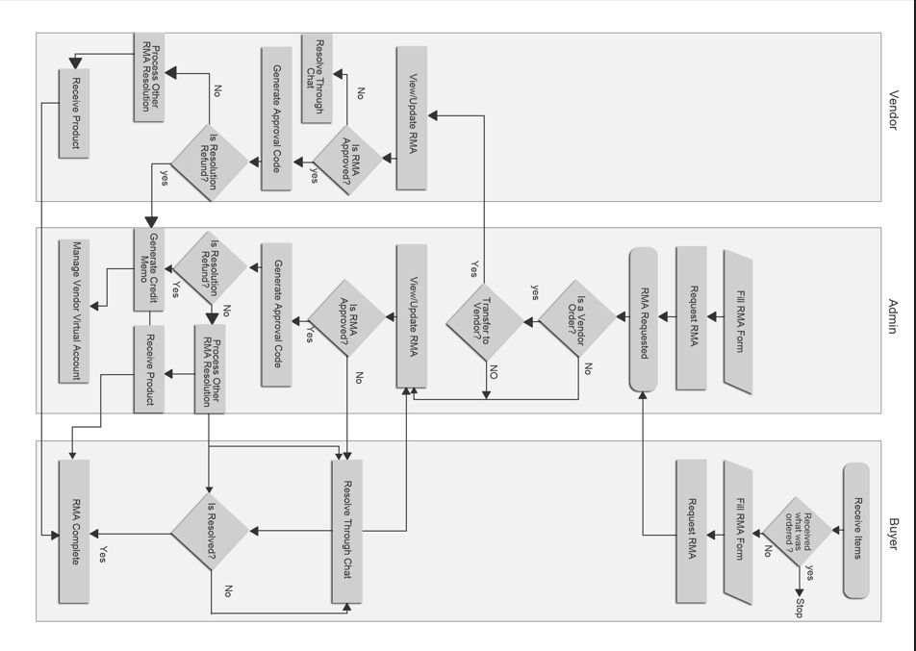

### **Approve RMA**

The RMA with an 'approved' status signifies that whatever may have been requested in the RMA has been approved by the vendor/admin. In the case of default different RMA Resolution Requests, we can have following conditions when RMA is approved:

#### **1) "Repair" Products-**

In case of combination of Repair and Approved a unique 'Approval Code' is generated and the admin can use this code for permitting any one Customer to send the product to the vendor by whatsoever medium the vendor wishes to fetch it.

Demonstrative Example-

Suppose that the vendor/admin provides a facility of door to door pickup of products, in that case the person collecting the items and the person returning can use this approval code as an authenticity for the other.

#### **2) "Replace" Products-**

In the case where the combination says “Approved Replaced Products”, a new order needs to be placed explicitly in the admin panel with the concerned amounts discount by admin itself for the exchanged product.

#### **3) "Refund" Products-**

If the request is to Refund Products and is approved, a credit memo is created in the admin panel for the concerned amount of the product.

Demonstrative Example-

Suppose the customer has ordered two products of X and Y amount and the amount totals to Z (X+Y=Z) in the placed order, then if the RMA is created for Product 1 of amount X, the Approved Refund will generate the Credit memo of amount X only.